🏥 Social innovation
Social innovation in health
Social innovation in health means creating and using new ideas to improve healthcare, especially for people who often do not have easy access to it. These ideas are made together with the community so they match real needs and work well in local situations. They can be new ways of working, community projects, mobile health services, education programs, or ways to connect traditional medicine with modern healthcare. The goal is to make health services more fair, easier to reach, and more effective.
Around the world, social innovation in health is supported by the Social Innovation in Health Initiative (SIHI), which started in 2014 with the World Health Organization’s TDR program, the Pan American Health Organization, and other partners. They help countries share experiences, train leaders, and grow projects so they can be used in more places. In different countries, this can mean mobile clinics, training community health workers, creating phone apps for health, or using art and culture to teach about disease prevention.
In Colombia, social innovation in health often means working directly with communities, including Indigenous groups like the Emberá. For example, in Pueblo Rico, projects with Minciencias, SIHI, and local organizations have created health materials such as radio programs, brochures, podcasts, TikTok videos, and songs in the Embera language. These share important health information while respecting traditions and culture. By creating solutions together with the people, these projects improve health knowledge, build trust, and help communities take part in decisions about their own health.

The SIHI LAC Hub is based at the Centro Internacional de Entrenamiento e Investigaciones Médicas (CIDEIM) in Colombia. This hub works to bring together experience, resources, and knowledge from different sectors to support social innovation in health across Latin America and the Caribbean. Their goal is to build strong networks, share lessons, and create evidence that shows how these innovations work and can be expanded.
SIHI LAC helps connect governments, universities, NGOs, communities, and private organizations so they can work together on health challenges. They focus on training people, promoting research, and making sure that successful projects are documented and shared. By combining the strengths of many partners, they make it easier for innovative health solutions to be used in more places and to have a bigger impact.
In Colombia, SIHI LAC at CIDEIM also works with Indigenous and Afro-descendant communities, making sure that health projects are culturally respectful and adapted to local needs. This means using community languages, respecting traditional medicine, and involving community leaders in decision-making, so that health services are not only available but also trusted and used.

SIHI Innovation 2017 // Comprehensive health approach to Chagas disease, Guatemala
Social innovation.mp3
Transcripción en español:
En 2009, Pamela Pennington, investigadora y docente de la Universidad del Valle de Guatemala, enfocó sus esfuerzos en contra de la enfermedad de Chagas con los habitantes de la comunidad de Comapa, un municipio del departamento de Jutiapa, al suroccidente de Guatemala, que cuenta con una población de un poco más de 28 mil personas. Mostraba los índices más altos de infestación y seropositividad en niños de todo Guatemala.
Es una enfermedad que se puede transmitir de madre a hijo. La pobreza lleva a que haya niños que nazcan con esta sentencia de muerte y personas que sigan viviendo con esto, afectándoles a corto plazo.
Las investigadoras Pennington y Sandra de Urioste, junto a un equipo interdisciplinario integrado por biólogos, personas formadas en ecoturismo, antropología y sociología, así como técnicos de campo con amplia experiencia en trabajo comunitario en zonas rurales de Guatemala, decidieron no predeterminar los factores de riesgo del Chagas, sino más bien establecer un diálogo participativo con las comunidades de Comapa para definir con ellas el enfoque del trabajo, identificar sus necesidades y establecer los mecanismos de intervención.
En un primer momento, se centraron los esfuerzos en reducir la posibilidad de reinfestación de los vectores, haciendo que el ambiente, fuera y dentro de las viviendas, fuera menos atractivo para los chinches.
Las universidades han sido de gran beneficio, ya que gracias a ellas se han podido desarrollar diversas actividades en las áreas de campo, específicamente en las áreas afectadas por los altos niveles de infestación de Chagas.
En un segundo momento, se enfocaron en mejorar la provisión de servicios de atención a pacientes con Chagas, diagnosticando la enfermedad con pruebas rápidas en el centro de salud de Comapa.
Finalmente, una tercera fase de la intervención consistió en identificar casos de transmisión del Chagas de madre a hijo en el momento de atender los partos. Sin embargo, como la mayoría de madres gestantes preferían parir en sus casas con ayuda de comadronas, se acercaron a ellas para que ayudaran a remitir a los bebés de un mes de nacidos al centro de salud y determinar si tenían o no la enfermedad.
Otra cosa que fortaleció el proyecto fue la estabilidad de una persona en las áreas donde se ejecutan los trabajos, lo cual permitió que el trabajo se desarrollara mejor, de manera más eficaz, y con mayor participación comunitaria, logrando así que las acciones fueran más eficientes en las zonas más afectadas por Chagas.
Se quisiera llevar esta estrategia a todas las comunidades vulnerables afectadas, para poder llegar a la meta final de la eliminación de la transmisión de esta enfermedad que afecta a la gente más pobre del país. Tal vez, si se pudiera llegar a nivel centroamericano, podría ser una de las metas a corto plazo con el financiamiento adecuado.

Traducción al inglés:
In 2009, Pamela Pennington, a researcher and professor at the Universidad del Valle de Guatemala, focused her efforts on combating Chagas disease with the inhabitants of the community of Comapa, a municipality in the department of Jutiapa, in southwestern Guatemala, with a population of just over 28,000 people. It showed the highest rates of infestation and seropositivity in children in all of Guatemala.
This is a disease that can be transmitted from mother to child. Poverty leads to children being born with this death sentence and people continuing to live with it, affecting them in the short term.
Researchers Pennington and Sandra de Urioste, together with an interdisciplinary team of biologists, professionals trained in ecotourism, anthropology and sociology, as well as field technicians with extensive experience in community work in rural areas of Guatemala, decided not to predetermine the risk factors for Chagas, but instead to establish a participatory dialogue with the communities of Comapa to define the focus of the work together, identify their needs, and establish mechanisms for intervention.
In the first stage, efforts were focused on reducing the possibility of reinfestation by the vectors, making the environment inside and outside homes less attractive to the insects.
The universities have been of great benefit, as thanks to them, various activities have been carried out in the field, specifically in the areas affected by the high levels of Chagas infestation.
In the second stage, the focus was on improving the provision of healthcare services to Chagas patients, diagnosing the disease with rapid tests at the Comapa health center.
Finally, a third phase of the intervention consisted of identifying cases of mother-to-child transmission of Chagas during childbirth. However, since most pregnant women preferred to give birth at home with the help of midwives, the team approached them so they could help refer newborn babies, at one month of age, to the health center to determine whether or not they had the disease.
Another factor that strengthened the project was having a permanent presence in the areas where the work was carried out, which made the work more effective and encouraged greater community participation, thus allowing actions to be carried out more efficiently in the areas most affected by Chagas.
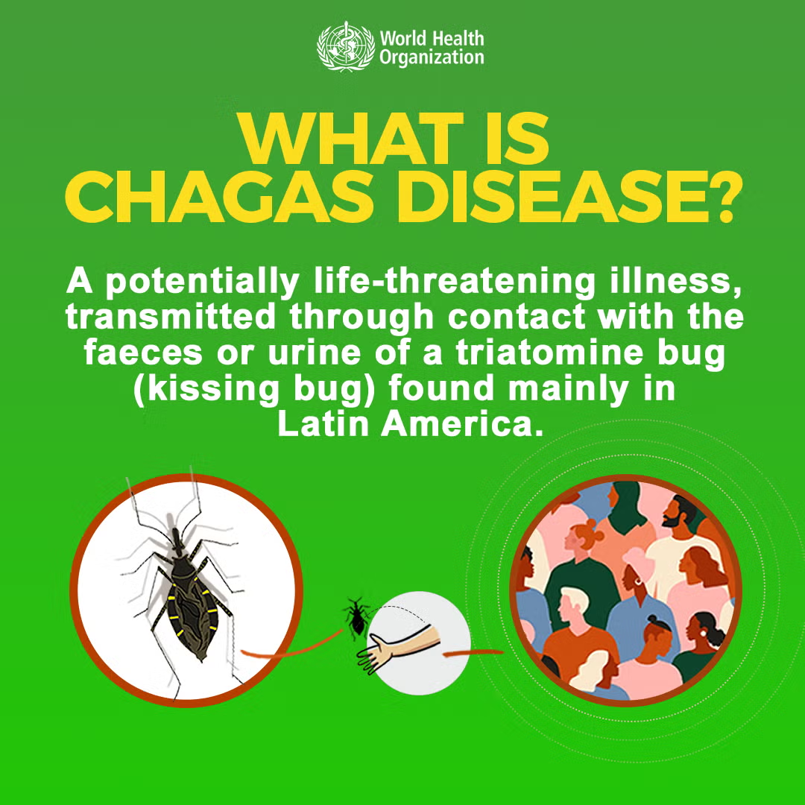
The goal is to bring this strategy to all vulnerable affected communities, in order to reach the ultimate aim of eliminating the transmission of this disease that affects the poorest people in the country. Perhaps, if it could be expanded to the Central American level, it could become a short-term goal with the right funding.

Questions for Milena
- Is this the first time you have heard about Chagas disease?
- What do you know or think about this disease?
- How do you think SIHI LAC and CIDEIM are helping communities affected by Chagas disease?
- In your own words, how would you define “social innovation in health” based on the Chagas disease case?
- How do you think indigenous communities, like the Emberá, could benefit from these innovations?
My short definition for reference:
Social innovation in health means creating new, community-based solutions to improve health and make services more accessible, especially in vulnerable or remote areas. In the Chagas disease case, it involves working with local people, health workers, and partners to detect the disease early, educate communities, and provide better access to treatment.

Listening exercise- True or False
Instructions for Milena

Milena, you are going to listen to a short audio about Chagas disease.

- In the first part, you will answer True or False questions based on what you hear.
- In the second part, you will answer Multiple Choice questions. For each question, you will choose the correct option: A, B, or C.
Listen carefully and answer according to the information from the audio.

Activity
Chagas is the deadliest.mp3
True and False
- Chagas is the deadliest parasitic disease in Latin America by number of deaths. _____
- Chagas is caused by a parasite called Trypanosoma cruzi. _____
- The insect that transmits Chagas feeds only on human blood. ______
Multiple Choice
4. What is the name for the insect that transmits Chagas in Guatemala?
a) Mosquito
b) Chinche
c) Fly
- Where can the transmitting insect hide inside homes?
a) Cracks in adobe or wooden walls
b) Under clean cement floors
c) Roofs made of palm leaves
- What happened in Comapa after spraying with insecticides?
a) The insect infestation completely disappeared
b) There were still high infestation rates and infected children
c) The insect only moved to urban areas

Answers
- True
- True
- False
- b) Chinche
- a) Cracks in adobe or wooden walls, c) Roofs made of palm leaves
- b) There were still high infestation rates and infected children

Chagas

Chagas is the deadliest (by number of deaths) parasitic disease in Latin America. It affects approximately 8 million people in the world, causing an estimated 10,000 deaths each year, especially in populations living in poverty. This disease is caused by the parasite Trypanosoma cruzi, which is transmitted by an insect (Triatomine bug) that in Guatemala is called a chinche. This insect feeds on the blood of dogs, birds, rodents, other animals and humans. It hides inside homes in crevices and cracks in adobe or wooden walls and poorly finished floors, and roofs made of palm leaves.
To eliminate the transmitting insect, in the decade of the 2000s, a strategy of massive spraying with insecticides was implemented throughout Guatemala. Despite this attempt, for the year 2010, the municipality of Comapa had high rates of reoccurrence of Chagas after spraying with insecticides. It also had one of the highest rates of infestation of chinches in homes, and children infected with the parasite.

